From: https://www.bloomberg.com/view/articles/2017-05-12/trump-s-dangerous-disability-it-s-the-dunning-kruger-effect

SCIENCE

Trump’s ‘Dangerous Disability’? It’s the Dunning-Kruger Effect
We’re all ignorant, but Trump takes it to a different level.
By
Faye Flam
93
May 12, 2017, 1:20 PM EDT
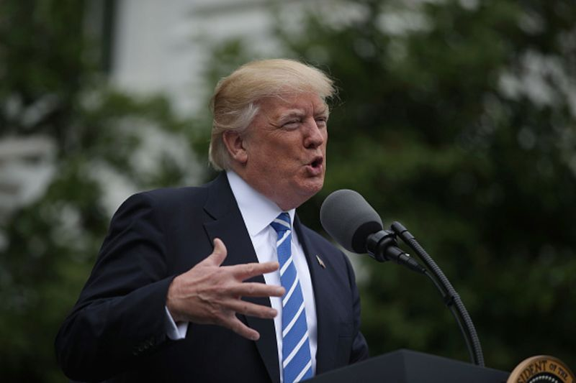
Unknown unknowns.
Photographer: Alex Wong/Getty Images
Last week, behavioral researchers at Brown University held a colloquium titled “Analytic thinking, bullshit receptivity, and fake news sensitivity.” At an informal gathering afterwards, the conversation turned to the not-completely-unrelated topic of Donald Trump.
Earlier that week, syndicated columnist George Will offered an amateur diagnosis of sorts. Will’s assessment, based on Trump’s off-base statements about the Civil War and other topics, was that the president suffers from a “dangerous disability” -- not only because he’s ignorant, and ignorant of his ignorance, but because he “does not know what it is to know something.”
It turns out Will is on to something, and not just because a few academics agree with him. His observations about Trump may have prompted him to independently discover a kind of meta-incompetence known as the Dunning-Kruger effect.
Brown cognitive psychologist Steven Sloman, who brought up Will’s column after the colloquium, is something of an expert on ignorance of one’s own ignorance. Earlier this year, he co-authored a book called “The Knowledge Illusion: Why We Never Think Alone.” The book describes a series of experiments in which people were asked to assess how much they knew about the way various systems work -- from toilets to single-payer health-care systems. People generally rated their knowledge of those systems as high -- but then, when asked to explain in detail how those systems actually worked, most couldn’t.
The guest speaker who talked about “bullshit receptivity,” psychologist Gordon Pennycook of Yale, has also done work on self-reflection and overconfidence. That put both of them in a good position to evaluate Will’s analysis of Trump.
- Neither went so far as to call Trump’s lack of self-awareness a disorder. Sloman said that the knowledge illusion is a common form of human fallibility, but Trump takes it to an exceptional degree. And for most people, the knowledge illusion is punctured once they realize they can’t explain heath care or toilets or zippers as well as they thought..] Not so Trump. When asked to explain something, he changes the subject, his confidence in his knowledge unwavering. [There are favorable as well as unfavorable was to understand this taken-to-an exceptional-degree behavior. –FNC]
And Trump’s assumptions of expertise go beyond ordinary appliances and policy issues. He recently advised the Navy on how to improve aircraft carrier technology: “It sounded bad to me. Digital. They have digital. What is digital? And it’s very complicated, you have to be Albert Einstein to figure it out.” [After the recent WannaCry ransomware attack this will make sense to a larger percent of folks. –FNC]
Both Sloman and Pennycook study a trait, called reflectivity, which can predict whether people are likely to be highly deluded about their own knowledge. The standard reflectivity test includes questions such as this: If it takes five machines five minutes to make five widgets, how long would it take 100 machines to make 100 widgets? And this: In a lake, there is a patch of lily pads. Every day, the patch doubles in size. If it takes 48 days for the patch to cover the entire lake, how long would it take for the patch to cover half of the lake?
For most people, these questions take a moment’s thought, though the less-reflective types will blurt out the most intuitive and wrong answer: It’s not 100 minutes for the widgets and not 24 days for the pond.
Pennycook borrows the definition of bullshit from philosopher Harry Frankfurt: information that’s presented with no concern for the truth. In an earlier study, he gave subjects randomly generated phrases such as “Hidden meaning transforms unparalleled abstract beauty,” which he called “pseudo-profound bullshit.” Low scores on the reflectivity test correlated with people seeing deep meaning in the statements.
In another recent paper, he examined the connection between reflectivity and the Dunning-Kruger effect. Named after psychologists David Dunning and Justin Kruger, the effect describes the way people who are the least competent at a task often rate their skills as exceptionally high because they are too ignorant to know what it would mean to have the skill.
Pennycook and his colleagues concluded that the Dunning-Kruger effect applies to people’s very ability to reason and reflect. They asked subjects to take a test of reflectivity and to guess how they did. Many of those who were unreflective thought they did well, since they had no idea what it would mean to be reflective and therefore were too incompetent to evaluate their own performance.
This is getting close to Will’s diagnosis of Donald Trump as a person who thinks he knows everything but in fact doesn’t know what it is to know something. The Dunning-Kruger effect and the knowledge illusion aren’t disorders, but are part and parcel of being human. Some people, however, are much more subject to these than others. And Trump seems to occupy an extreme end of the spectrum.
Is there any hope for Trump? His experience as president may make him more aware of how little he knows, said Sloman. Trump recently told reporters, for example, that “Nobody knew health care was so complicated.” He couldn’t quite bring himself to admit being wrong without sharing the blame with the rest of the world -– but perhaps it’s a start.
This column does not necessarily reflect the opinion of the editorial board or Bloomberg LP and its owners.
[ It does not necessarily reflect my opinion, either.
- Note that neither Dunning nor Kruger were apparently present at this Bull Session held after the Symposium.
- A rather funny but very political video showed up on Facebook, apparently the same week (day?) as this online Flam piece in Bloomberg News. The video attempts to educate the happily amused viewer about the Dunning-Kruger effect. As it applies to ---- Donald Trump. One thing is for sure here. That video was not cheap! It was not knocked out in somebody’s dorm room overnight for our amusement. And it tries to be scientifically accurate. It really tries to be but seems stop at about the point that Cook, Nuccitelli, et al. got to on 15 May, 2013 in their efforts to Quantify AGW Acceptance at 97%.
-FNC]

To contact the author of this story:
Faye Flam at fflam1@bloomberg.net

There are lots of videos on the Dunning-Kruger bias, going back several years, if not all the way back to the original 1999 social sciences article by Dunning and Kruger. If you include Trump and 2017 in your search you will easily find this version. This version of the video is in the Huffington Post, within an article dated 05/12/2017 05:05 am ET. The video takes 7 minutes to watch. The article is titled Stephen Fry Explains Why Some People Believe Everything Donald Trump Says. Stephen Fry, the actor in the article title, apparently does the voicing. A person named Ed Mazza appears to have done the brief text body. It is not clear who wrote “The incompetent are often blessed with an inappropriate confidence.” Over the video. You’re only a minute into the video before we get down to business. “Could the Dunning-Kruger effect explain some of Trump’s actions?” Soon, we’re into a complete redo of the 2016 election (Clinton version). Except, thank God, the (bipartisan) excesses of the War party are excoriated along with graphic examples of Trump’s meta-incompetence asserted to arise from his vulnerability to the Dunning-Kruger effect.

